Quadrants of abdomen
Abdomen can be arbitrarily divided by a midsagittal plane and transumbilical plane into four quadrants – right upper quadrant, left upper quadrant, right lower quadrant and left lower quadrant.
Abdomen is divided into nine regions by by two vertical planes – midclavicular planes (right and left) and two horinzontal planes – transpyloric plane and transtubercular plane into nine regions.
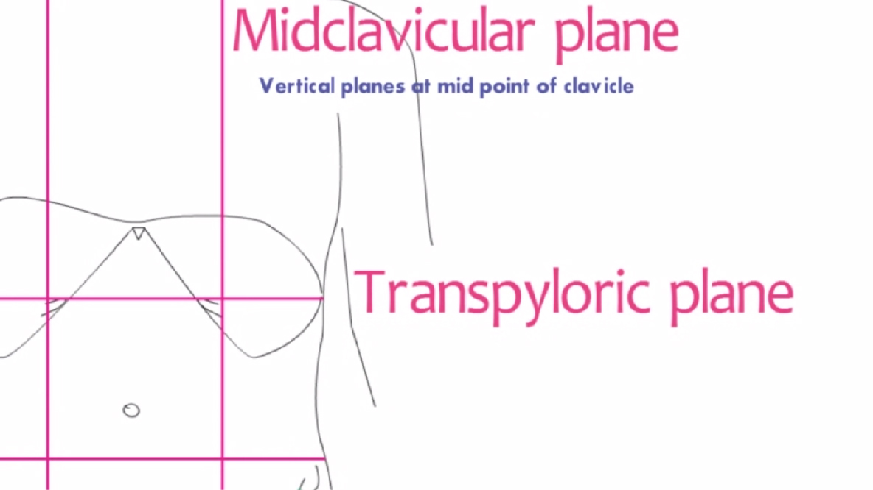
Transpyloric plane of Addison: Midway between lower end of sternum and umbilicus; lies at the level of ninth costal cartilage
Transtubercular plane: plane joining two iliac tubercles on iliac crests; lies 5cm posterior to anterior superior iliac spines; corresponds to upper border of L5 vertebra.
[TIP]Appreciate the planes
[YOUTUBE]https://youtu.be/rTM_KKLxE-M
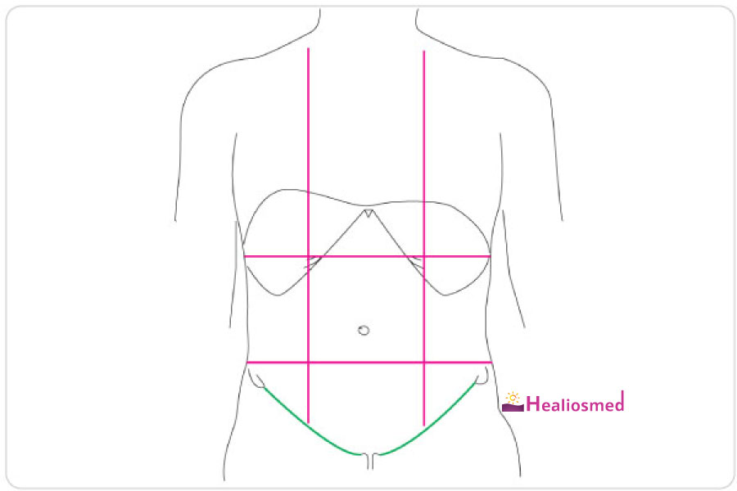
[CLINICAL]External genitalia is considered as tenth region of the abdomen – abdominal examination is not complete without examination of genitals
[SVG] quadrants outline.svg[/SVG]

Synonyms
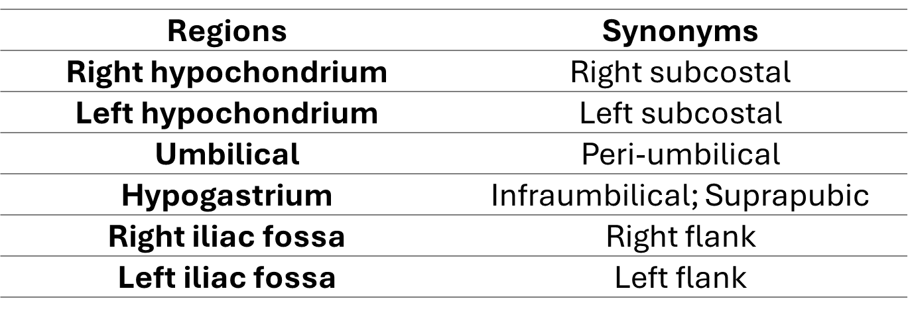
[TIP]Right lower quadrant ≠ Right iliac fossa

Abdominal regions and important contents
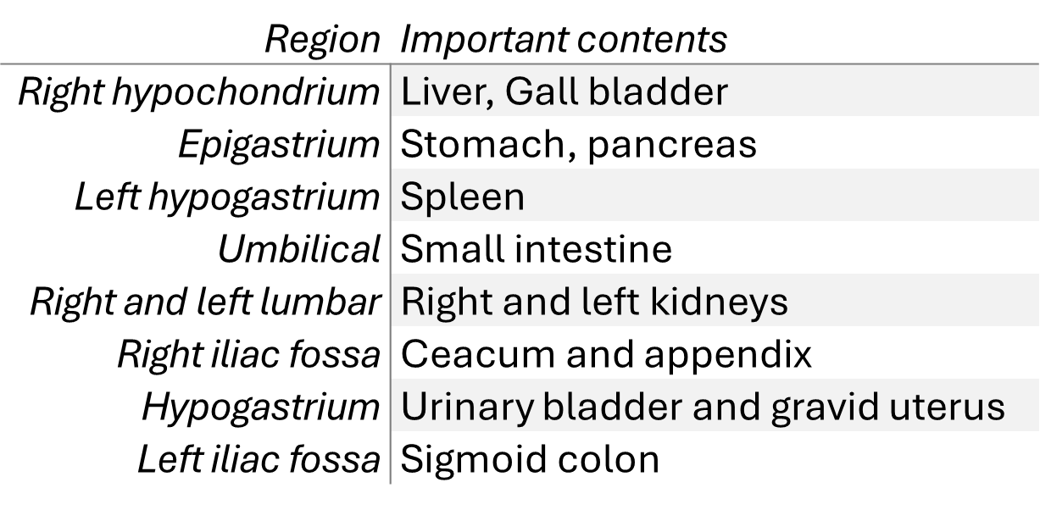

Nine sites of abdominal pain
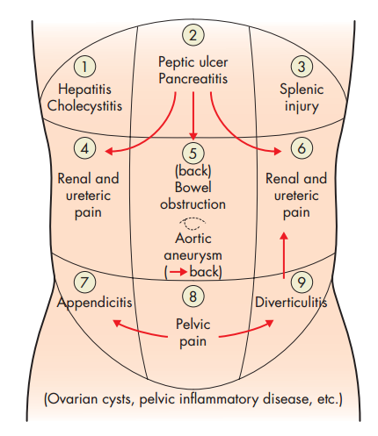

Common sites of referred pain from abdomen
